

**Questionnaire: Attitude to Risk**

**Name: Date: 2024**

# Signature:

**Financial Adviser:** Andrew Rowland/Sandra D’Arcy

Please complete the questionnaire and return it to your financial adviser.

**RISK PROFILE:**

# Question 1

**What is your main investment goal?** *Quick tip (Think about what you are saving for. Do you expect your savings to grow for a future payout, for example, retirement, a child's education, or to increase your money or leave an inheritance? Or will you use these savings to add to your income immediately?)*

[ ] A.Income [ ] B.Growth

# Question 2

**Investing comes with the possibility of losing some of the money you have invested. In an effort to achieve a higher return than an investment such as a bank account, do you accept a degree of risk with your money?**

[ ] A. Yes, I understand that investments can rise and fall in value and that I could lose some of my money.

[ ] B. No, I am not willing to see my money fall in value or lose any part of my investment.

# Question 3

**What impact would it have on your standard of living if you were to lose money on this investment?** *Quick tip (Losing money here refers to the value of your investment portfolio falling below the amount you originally invested because of a drop in the market. For example, if you gave your adviser £50,000 to invest and later the value of your investments fell to £47,500.)*

[ ] A. It wouldn't have an impact on my standard of living, and I wouldn't need to use any additional resources (for example, savings) as a result.

[ ] B.I have other resources I could fall back on.

[ ] C. It would have an impact on my immediate standard of living.

# Question 4

**When do you want to start spending the money you will save in this account?**

[ ] A. Immediately or within the next three years [ ] B. Within three to four years

[ ] C. Within five to six years

[ ] D. Within seven to 10 years

[ ] E. Not within the next 10 years

# Question 5

**Once you start spending your money, how long do you expect to continue to withdraw funds from your investment portfolio?** *Quick tip (Do you want to spend all your money at once, for example to buy a house? Or do you plan to make the money last over a longer period, for example by paying yourself a yearly income once you retire?)*

[ ] A. I plan to withdraw all of my money at once.

[ ] B. I will make withdrawals over two to five years. [ ] C. I will make withdrawals over six to 10 years.

[ ] D. I will make withdrawals over 10 years or more. [ ] E. I don't intend to withdraw the money.

# Question 6

**Once you start to spend the money in your investment portfolio, how much do you plan to withdraw?** *Quick tip (If your investments are worth £100,000 and you want to withdraw a yearly income of 4%, you will need to take out £4,000 each year.)*

[ ] A. I do not intend to take withdrawals.

[ ] B. I plan to withdrawal between 0% and 4% of the value of my investments each year. [ ] C. I plan to withdraw between 4% and 8% of the value of my investments each year.

[ ] D. I plan to withdraw more than half of the value of my investments within three to 10 years.

[ ] E. I plan to withdraw all of my investments at once.

# Question 7

**Some investments offer the opportunity for a greater gain but with the risk of a greater potential loss. Look at the five scenarios represented below. Which one would you put your money in?**

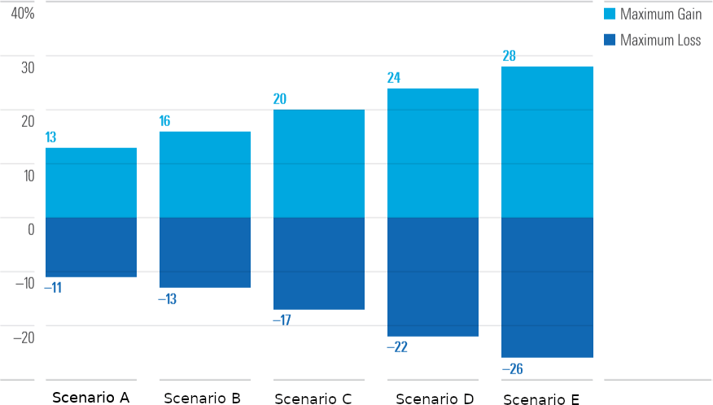

[ ] Scenario A [ ] Scenario B [ ] Scenario C [ ] Scenario D [ ] Scenario E

# Question 8

**Imagine you have invested £100,000. Which of the five scenarios below would you want for your investment portfolio?**

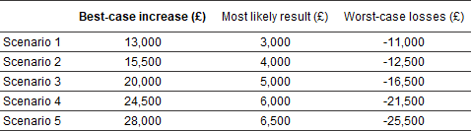

[ ] Scenario 1 [ ] Scenario 2 [ ] Scenario 3 [ ] Scenario 4 [ ] Scenario 5

# Question 9

**Investing involves a trade-off between risk and returns. In the past, investments with higher returns have been associated with greater risk and chance of loss. Whereas cautious investments that have had a lower chance of loss also have achieved lower returns. Which of the following statements best describes your attitude to risk?**

[ ] A. I am most concerned with risk. I am willing to accept lower returns in order to limit the risk of loss.

[ ] B. I am willing to accept some risk and chance of loss in an effort to achieve modest but somewhat higher returns.

[ ] C. I am willing to accept moderate risk in order to achieve higher returns. Reducing risk and increasing returns are equally important to me.

[ ] D. I want to achieve strong returns on my investments. I am willing to accept somewhat higher risk and chance of loss.

[ ] E. I am mainly concerned with getting the highest possible returns on my investments. I am willing to accept significant rises and falls in the value of my investments and a significant chance of loss.

# Question 10

**Imagine your adviser has invested £100,000 of your money and it's fallen in value to £80,000. Assuming that this happens at an early stage of your intended investment period, how would you react to this £20,000 loss?**

[ ] A. I would not change my investment plan.

[ ] B. I would wait at least one year before changing to investment options that are more stable.

[ ] C. I would wait at least six months before changing to investment options that are more stable.

[ ] D. I would immediately change to investment options that are more stable.

# Question 11

**The value of investments varies from year to year. Suppose you invested £100,000. How much money would you need to lose before you wanted to move your money into a more stable investment?**

[ ] A. £5,000 or less [ ] B. £10,000

[ ] C. £15,000

[ ] D. £20,000

[ ] E. It is unlikely I will move my money even if my investment falls in value.

# Question 12

**How does your concern about losing money manifest itself in relation to your investment?**

[ ] A. I would sell my investments.

[ ] B. I would be worried but not uncomfortable enough to sell my investments immediately. If my investments suffered losses over several months, I would probably sell.

[ ] C. I would wait a full year before making changes to my investments - short-term losses in the value of my investments do not bother me.

[ ] D. I would not make changes - I understand that investments can have occasional negative yearly returns. However, I have a higher chance of reaching my investment goals if I stick with my investment over the long term.

# Question 13

**Which of the following best describes your view on investing?**

[ ] A. My investments don't have to grow, I just want my money to be safe. [ ] B. I can accept lower growth for greater certainty.

[ ] C. I am more concerned about the possible losses than the possible gains. [ ] D. I can accept possible losses for long-term investment growth.

[ ] E. To achieve high levels of growth, it is necessary to take risk.

**ESG – Environmental, Social and Governance investing**

Ethical and socially responsible investments have become a feature of investment strategies to meet the needs of clients who wish to avoid certain sectors – arms, fossil fuels etc. However, over recent years this has been extended to companies who wish to act socially responsibly in terms of working practices and how they source their materials and goods. In addition, this is extended to firms seeking new approaches to established economic demands such as a move to electric cars, renewable energy, developments into hydrogen as a source of power etc. These changes present many investment opportunities and are a future source of investment which will continue in the years ahead as governments seek to meet climate change goals and companies develop new strategies.

If you wish to discuss these growing investment opportunities or wish to take account of them when we consider the allocation of your portfolio, please confirm this to us:

I would like to discuss this in more detail Yes / No

I would like to have an allocation in the portfolio that takes account of ESG Yes / No

If yes, please note the percentage %

**Client comments:**

ESH allocation is in place and will be reviewed to consider the percentage allocation